Squeezing Air

Materials: 2 syringes

1. Put your finger over the hole in the end of the syringe. Try to push in the plunger. What happens?

2. Here is picture A of the syringe with the molecules of air in it.
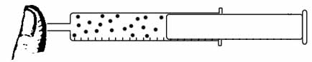

Here is picture B of the syringe after you push in the plunger. Remember that there’s the same number of molecules inside the syringe. Draw how the molecules in the syringe look now. 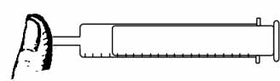
Now what happens when you let go of the plunger? Why does it happen?

In each box, draw what the air molecules look like in low air pressure and in high air pressure.

Low air pressure High air pressure

Air Pressure and Wind

Part I
You have a set of materials on your table. In your group, use them to figure out how many different ways you can make wind blow. Be prepared to show the class your favorite way to make wind blow. In your demonstration, you must explain what is happening to the air

Part II.
Blow up your balloon as big as you can and tie off the end. Now use your scissors to cut the balloon partway across just above the knot. What happens?

Divide your whiteboard in half. On one side, construct an explanation of what happened to the balloon. Your explanation should include words and pictures. You should illustrate the air particles inside and outside the balloon, and use the concept of air pressure in your explanation.

Part III.
Now expand your explanation to include at least two other ways that you made wind in part I, still using the concept of air pressure to explain wind. Illustrate your explanation on the other half of your whiteboard.

Part IV.
Erase your whiteboard. Now use the model of air pressure and wind to explain some or all of these phenomena in words and pictures:

- how a bicycle pump works
- how a fan works
- how a vacuum cleaner works

In each case, be sure to label where there are areas of high or low air pressure, and which way air moves.

Part V.
In your journal, write a simple rule about wind and air pressure. Then write a brief explanation of the rule.

Air Pressure and Altitude

Part I.
What does your team know about how air pressure and altitude are related? On your whiteboard, make a drawing that illustrates your current understanding of the relationship and why it exists.

Part II.
Complete the worksheet. Reconsider your explanation for the relationship between air pressure and altitude. Change it if you wish.

Part III.
Now use your model for air pressure and altitude to explain some or all of these phenomena. Draw your explanation on your whiteboard.

- Potato chip bags expand when you take them to Lake Tahoe
- People who train in Sacramento can’t run as far at Lake Tahoe
- You get chapped skin and sunburns more easily in the mountains.
- Water boils at a lower temperature at higher elevations (that’s why there are different cooking times for cakes baked at high elevation)

